Issue 28 21 st April 2025

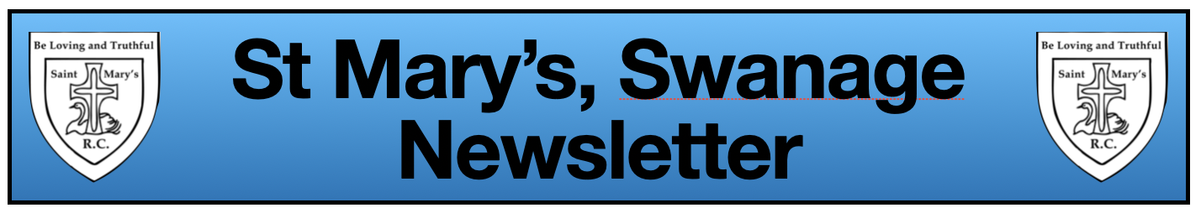

**Attendance - 93.92%**

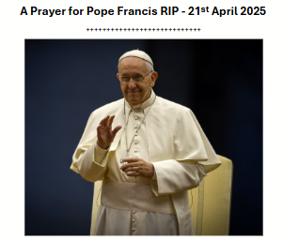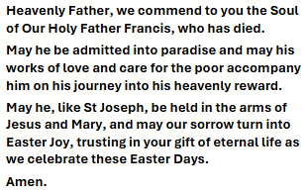

**Easter Mass**

We had a lovely mass to celebrate Easter today – you are always welcome to join us for Mass; the dates are on the parent noticeboard and in the newsletter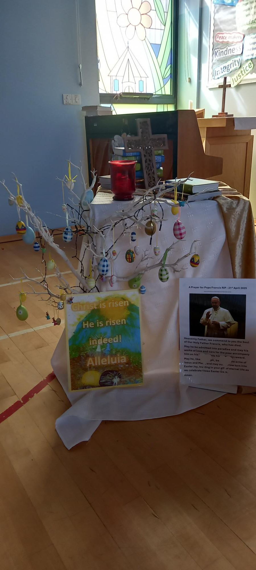

**New Bibles**

We are delighted to have some new sets of Bibles in school partly funded by ‘Bibles for Schools’ with a contribution of 50p per Bible from the FOSM – many thanks to them. As always, for all their support. Each child in years 2/3/4/5/6 will receive their own personal Bible for use in RE lessons. When they leave year 3 and year 6, they will be able to bring these home to keep and as they enter years 2 and 4, they will receive a new copy.

|  |  |
| --- | --- |
| **Reception** | Reception has been very busy in their first week back at school. They were very excited to have a visit from ‘The Evil Pea’ from the story *‘Supertato’.* ‘The Evil Pea’has caused a bit of trouble, but after solving all the clues and some top investigation work, we have managed to get our house points back from him! In Maths, we have been continuing to work on repeated patterns and have been spotting patterns around the school. |
| **Year 1** | Year 1 has worked very hard this week! In Maths, we completed our work on capacity and volume by estimating which container could hold more and then filling jugs with water. We have now started looking at mass and how much an item weighs. In Geography, we have started our new topic of looking at our local area and have considered the differences between urban and rural places. In English, we are still enjoying our text, The Snow Queen. In Art, we have thought about how we can make different patterns and draw some wonderful examples of our own. Keep up the brilliant work, Year 1! |
| **Year 2** | Year 2 has returned to school with a great attitude and started working hard immediately! We have started a new class text, *Samson’s Titanic Adventure,* and have enjoyed finding out what happens to the little mouse and how it matches what we know about the Titanic from our work in our History lessons. As part of our history topic of the Titanic, we have looked at how ships have changed over time, putting pictures of key ships in chronological order and thinking about the effect of these changes. In Maths, we have finished our measuring topic by answering reasoning questions using the four different mathematical operations. In Art, we have started looking at how we create different tones with just one coloured pencil by using varying amounts of pressure. Keep up the great work, Team 2.6! |
| **Year 3** | It has been a busy first week back for Year 3. In Maths, we have been using our prior knowledge to help us to easily multiple by ten. Although some found it a little tricky to begin with, we have been making lots of positive progress. In English, we wrote some recounts of our Easter holidays. It was lovely to hear and read about all the exciting things that have been happening at home. We have also started our new class text ‘Song of the Dolphin Boy’. We looked at the front cover and then each student wrote an ‘I wonder if........’ statement which have been added to our English working wall. We also began looking at extracting setting descriptions from the text and converting them into bullet points. We are going to use these bullet points to support us in writing about the setting in our own words. This term’s History topic is ‘Ancient Civilisations’, we have begun to look at timelines and to identify the earliest civilisations and when they occurred in history.  It was lovely to welcome the children back and we look forward to updating you with all our new learning as we progress through this half term. |
| **Year 4** | Year 4 has had an excellent first week back. We’ve started a new class text, Fair’s Fair. We’ve also been learning about letter writing, looking at the features and the tone you should use when writing a formal letter. In Maths we’ve come to the end of our learning about decimals, and we will be starting our new topic next week. In History we have started our new topic ‘Victorian Swanage’ and the children have enjoyed learning about some key dates and events during the Victorian era. Well done Year 4 for an excellent first week back. |
| **Year 5** | It’was lovely to have Year 5 back and they have got off to a flyer! In Maths, we have been learning how to reflect shapes using a mirror and have also focused on the importance of reflecting in the mirror line. In PE, we completed a fitness circuit and enjoyed our first game of cricket in the season (summer has arrived!). We are very much looking forward to starting our new History topic looking at the Viking and Saxon struggle for England up to the time of Edward the Confessor. |
| **Year 6** | Year 6 has returned with much enthusiasm! We started to learn about classification in science, having a go at being ‘taxonomists’ and attempting to group animals for our own zoo enclosures. We have also started our new topic of the Ancient Maya, looking at where and when they existed. In English, we completed our newspaper reports using the chrome books and will move onto another class text *‘The Silver Sword’* next week. Tomorrow, many children will represent the school in the final of the Indoor Athletics Competition in Weymouth and the remaining pupils are going to work with Darrell Wakelam; a visiting artist who will create some 3d sculptures which will be on display at Rollington Barn during the Purbeck Art Weeks. |

**The Sports Report**

The **Purbeck Cup Final** for boys will take place on **Tuesday 29th April** at **3.15**. Spectators are welcome.

**St. Mary’s Class Stars**

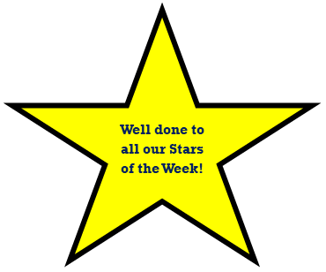

**Reception:** *Arthur & Willow*

**Year 1:** *Connor & Jessica*

**Year 2:** *Aurora & Luna*

**Year 3:** *Saoirse & Charlie R*

**Year 4:** *Arlo & India*

**Year 5:** *Nico & Lydia*

**Year 6:** *George & Noah*

**Whole Class Stars**

**Year 4:** for their brilliant behaviour and participation in all activities while on their residential trip to Leeson House at the end of last term; they were a credit to the school.