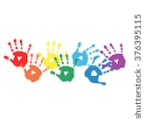
My Book About
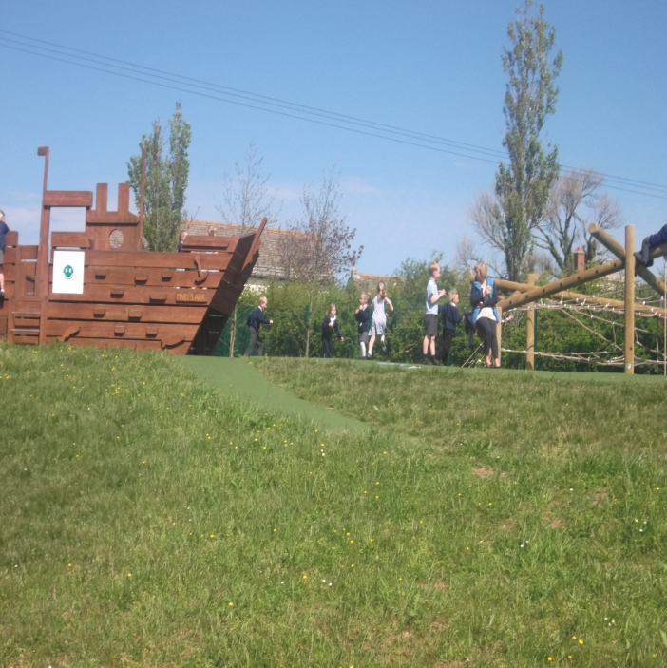
Big School
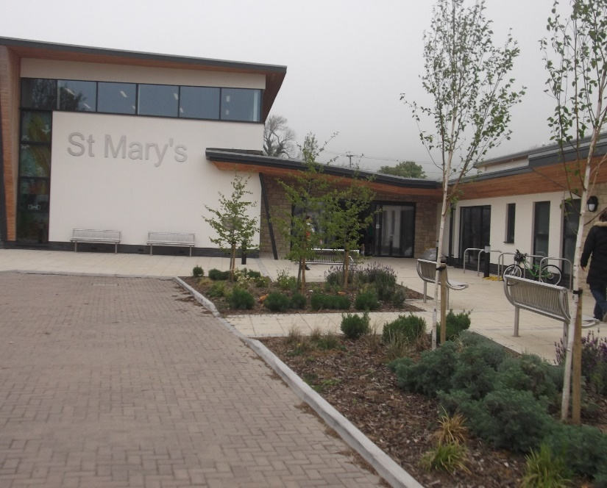

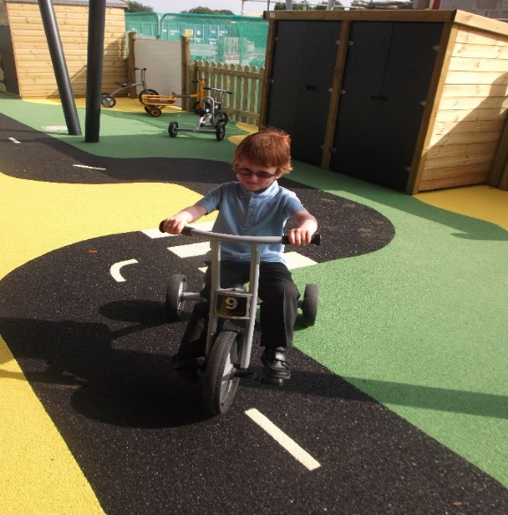
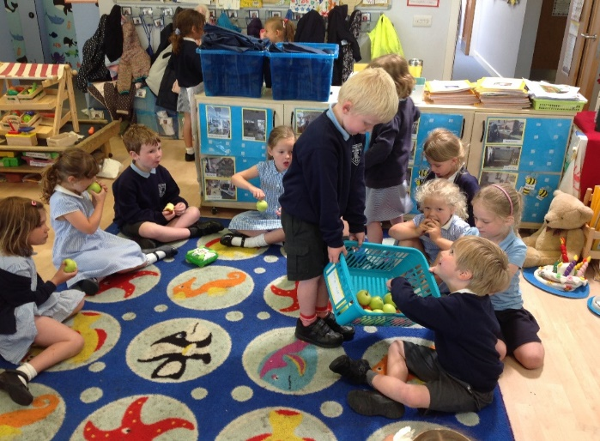
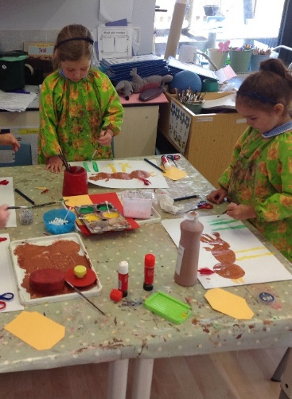
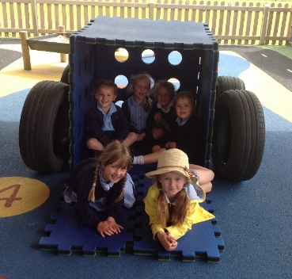
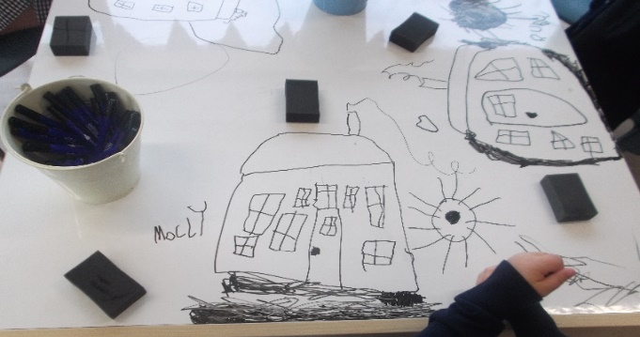
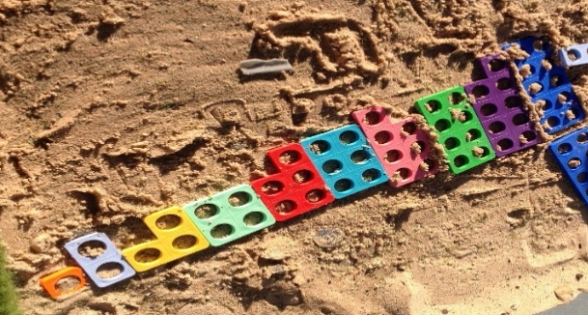

Hello

We are really looking forward to you starting big school. We have made you a photo book to tell you all about big school. You can look at this book with your family and talk about the pictures.

When you start school you will have teachers who will help you just like at Preschool.

My name is My name is
Mrs Gray Mrs Jewell
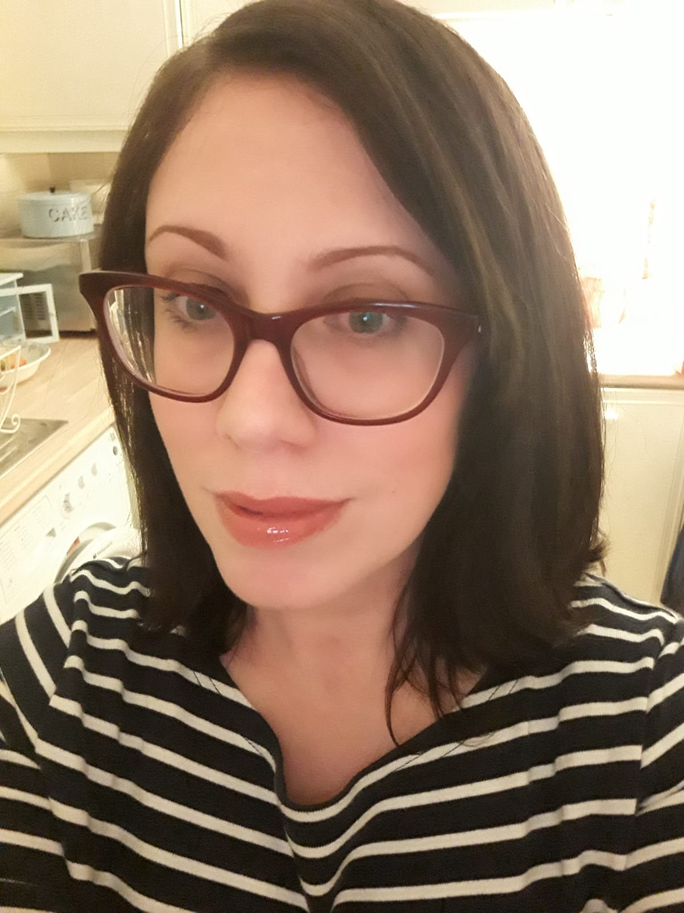
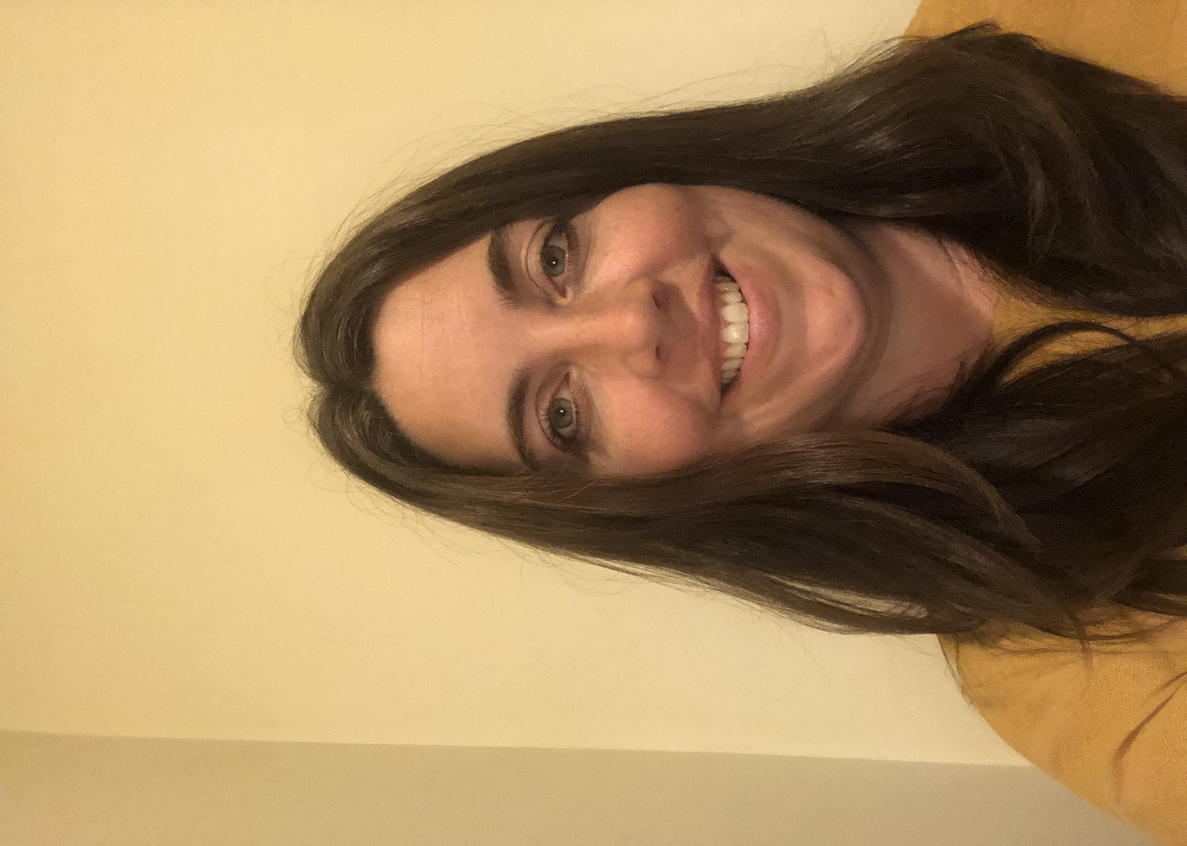

This is your new classroom:
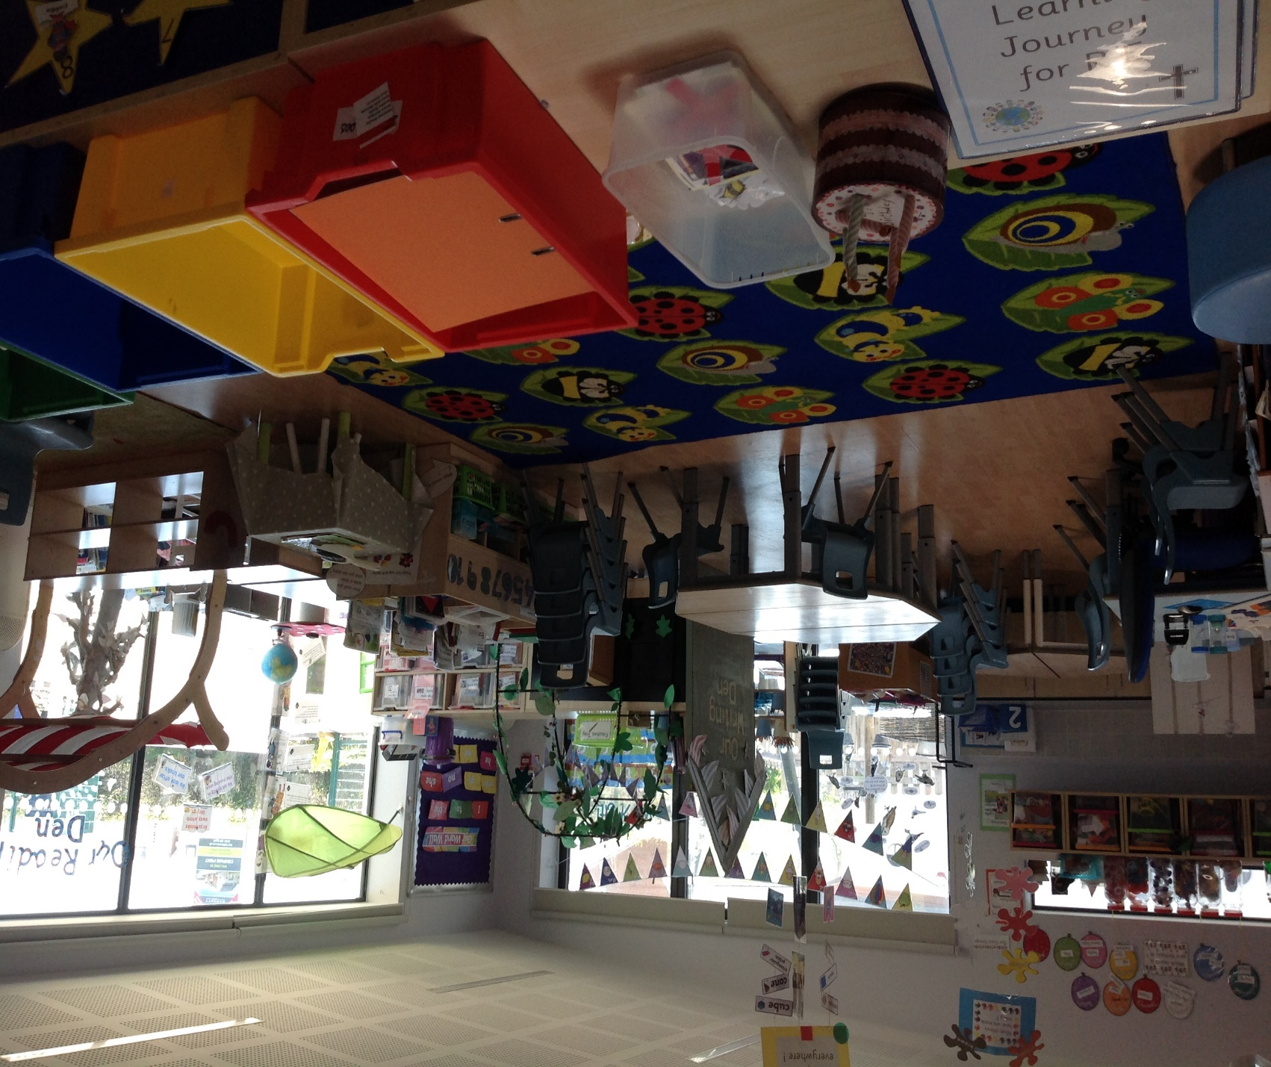

We have lots of places to explore and toys to play with.

We have a reading den where you can look at books.
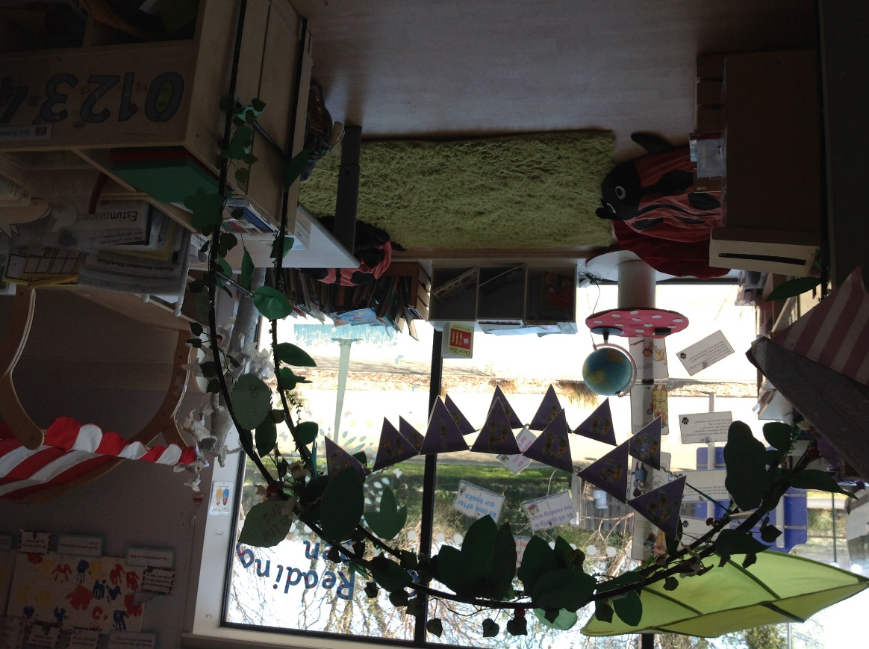

We have a writing den where you can draw pictures and make marks with pencils, crayons, chalks and pens.
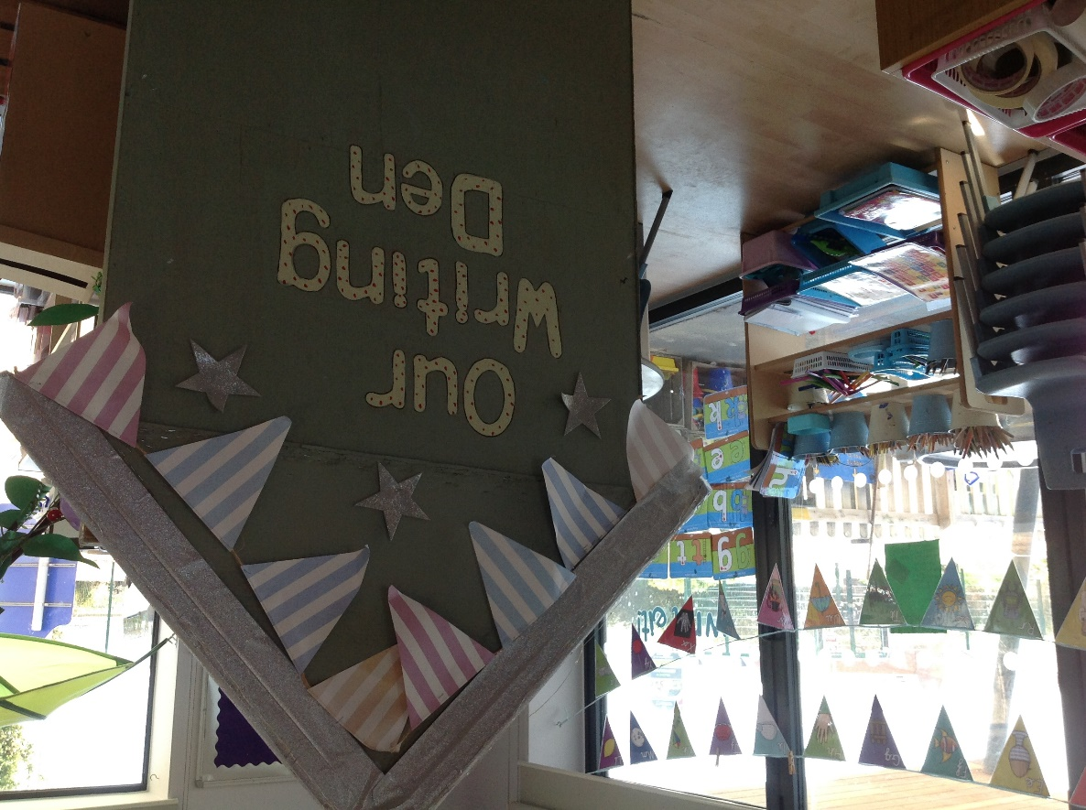

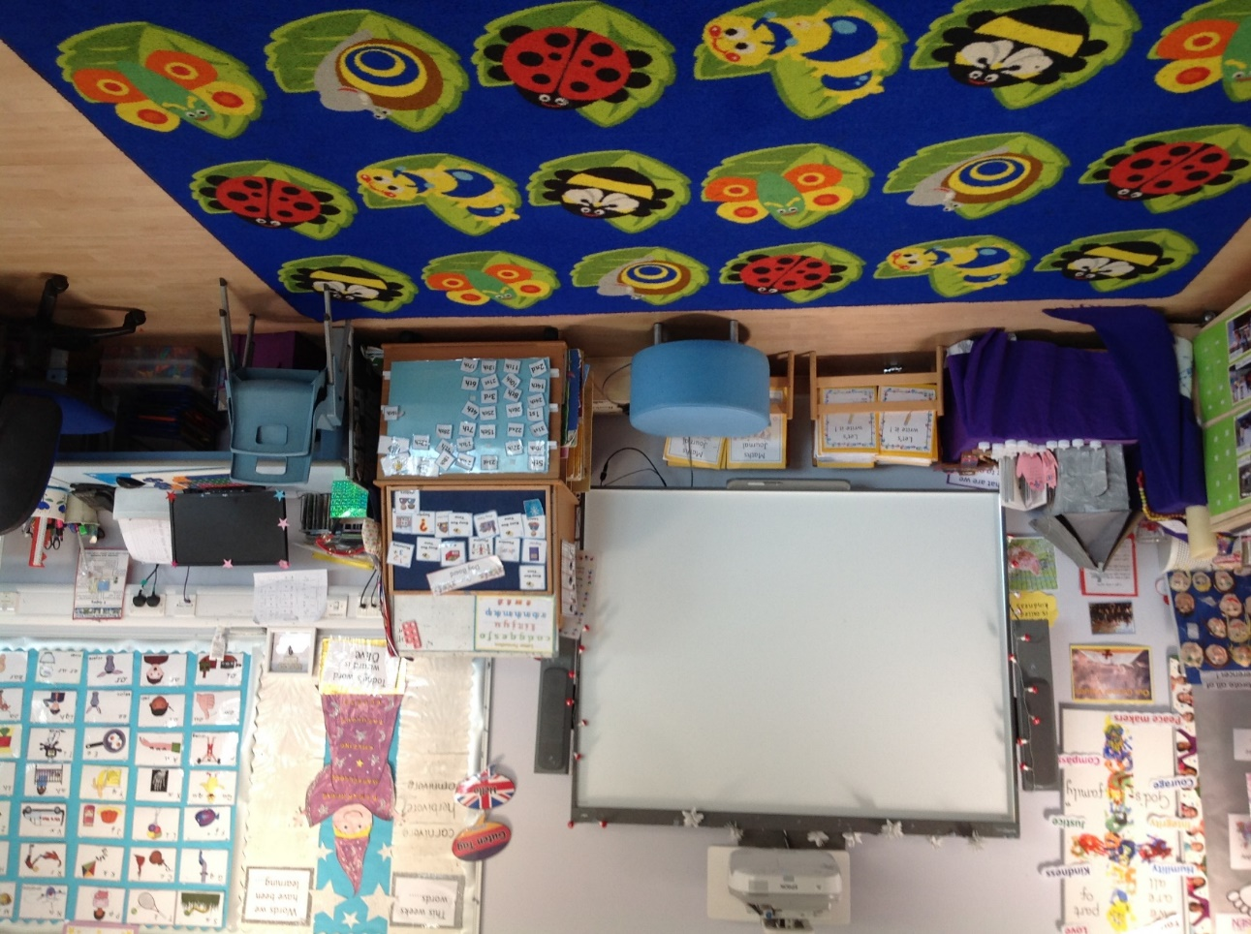
There is a big carpet where we sit to learn sometimes. We have a big white board which we can listen to stories and play games on.
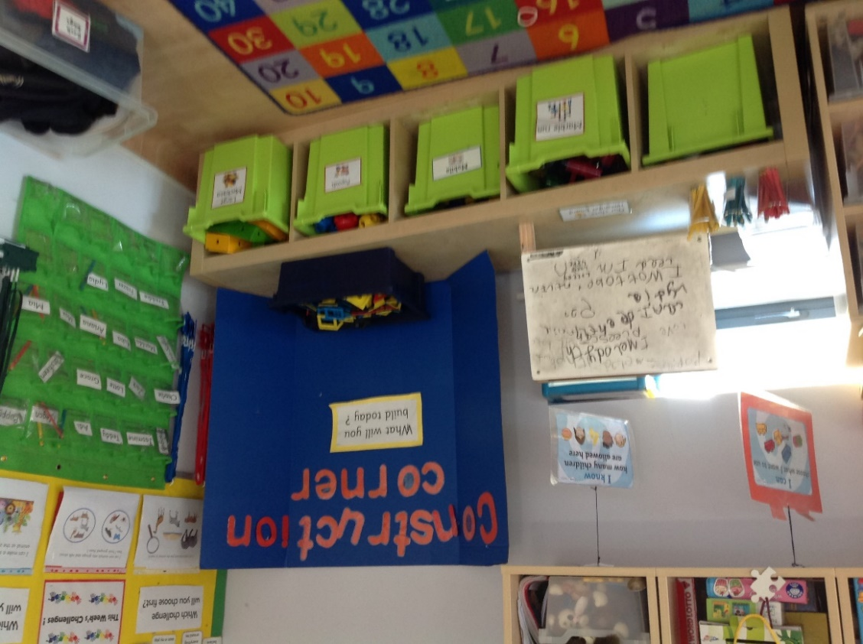
We have an area for building with Lego, blocks and other building toys.

This is our busy bee board. You can choose where you would like to play and put your name next to the picture to show where you are exploring.
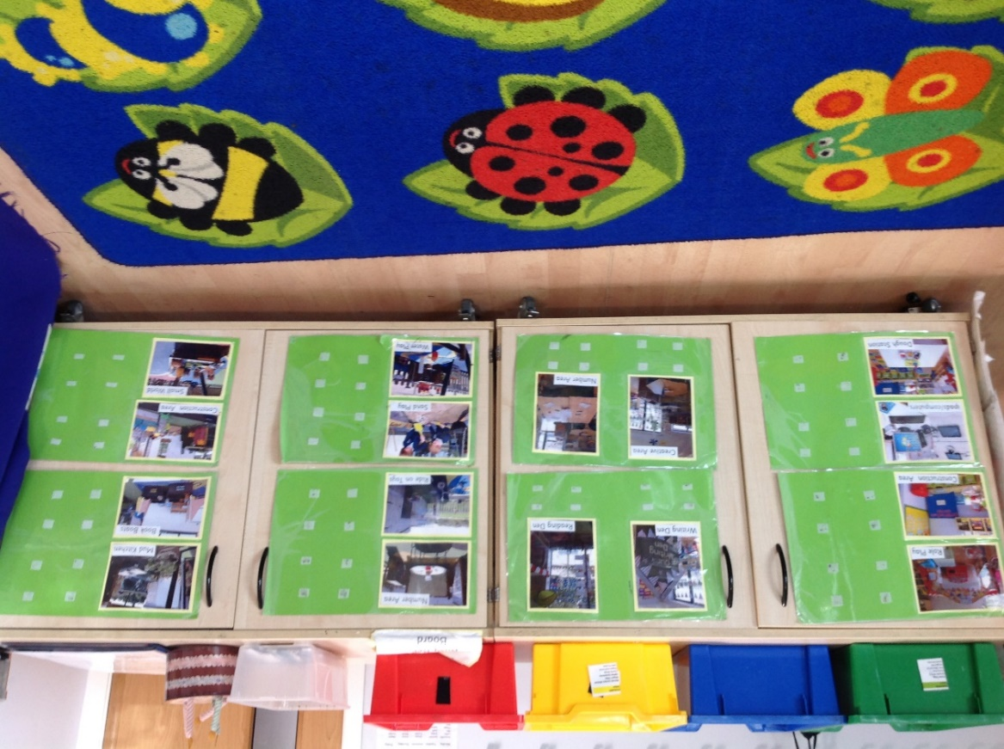

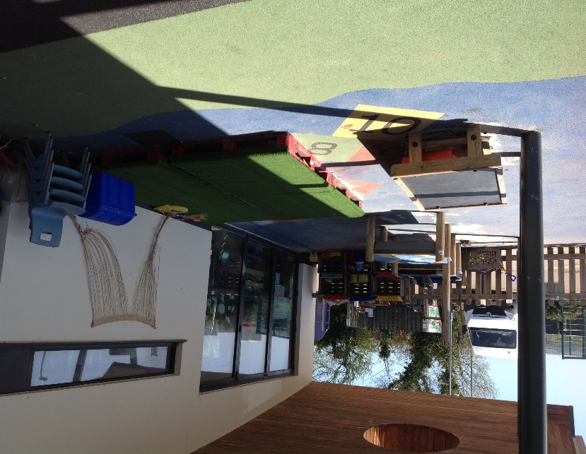
We also have an outside classroom to play in
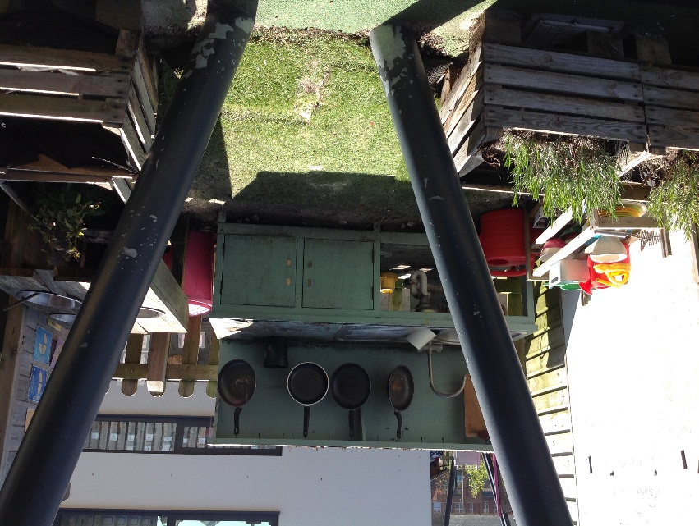
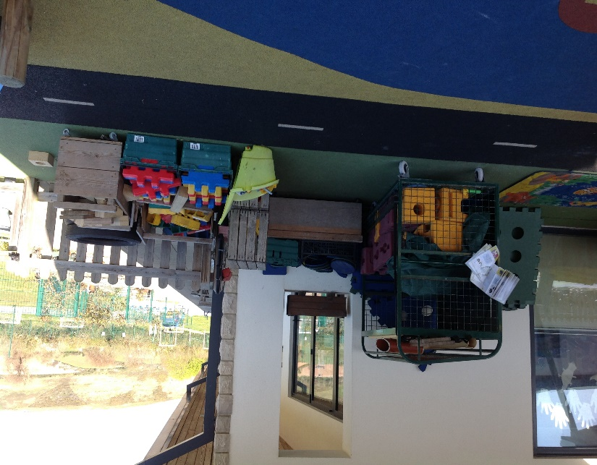
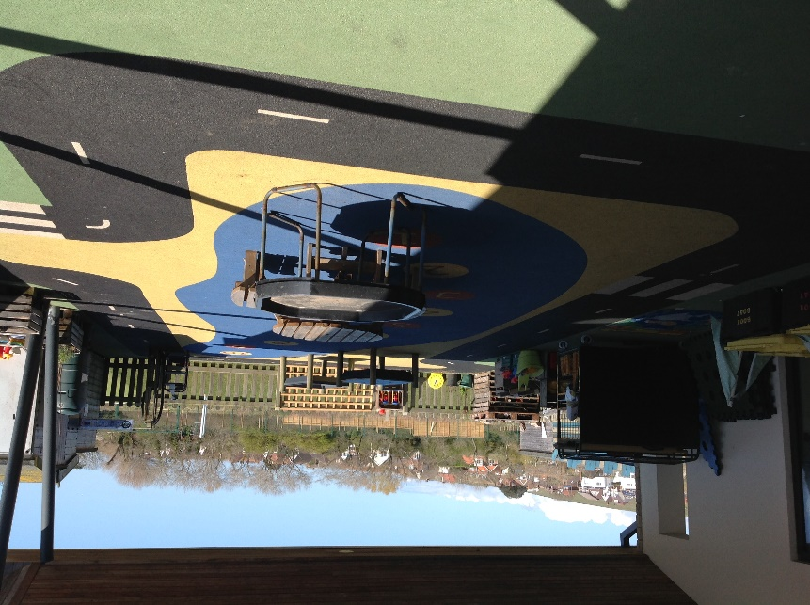

This is our playground where you can play with your friends for some time in the morning, after lunch and at the end of the afternoon.

In the morning you put your school bag in the coloured box that is the same as your school house. Then you put your name on a star to show you are at school.
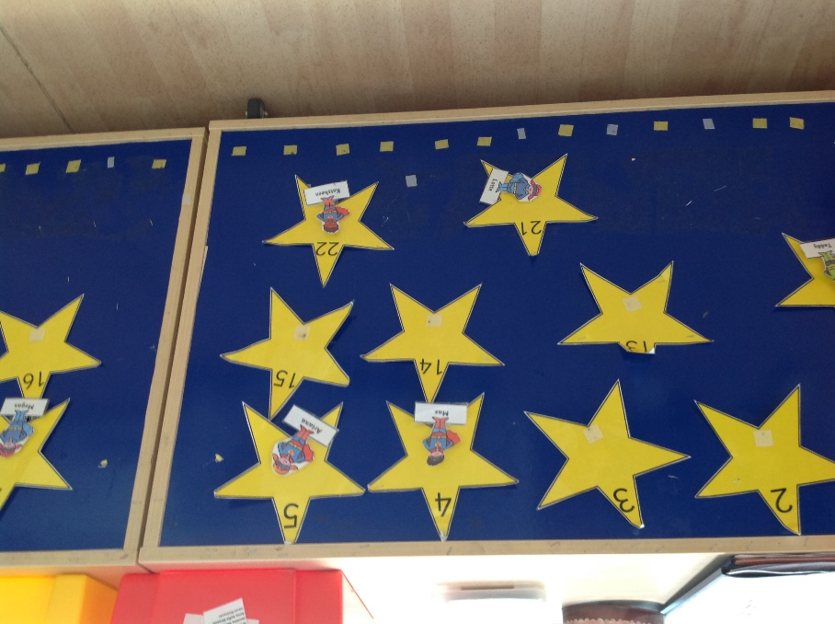
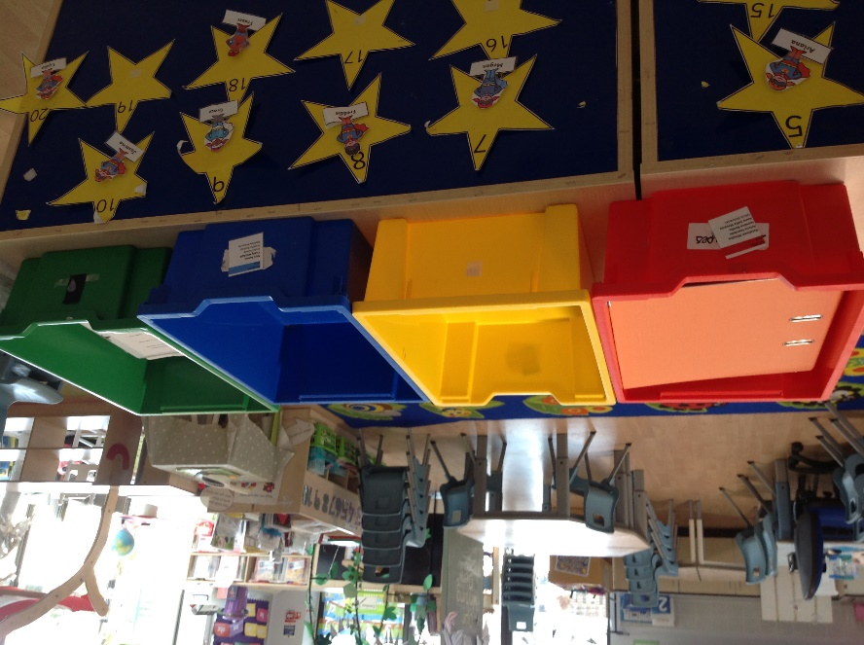

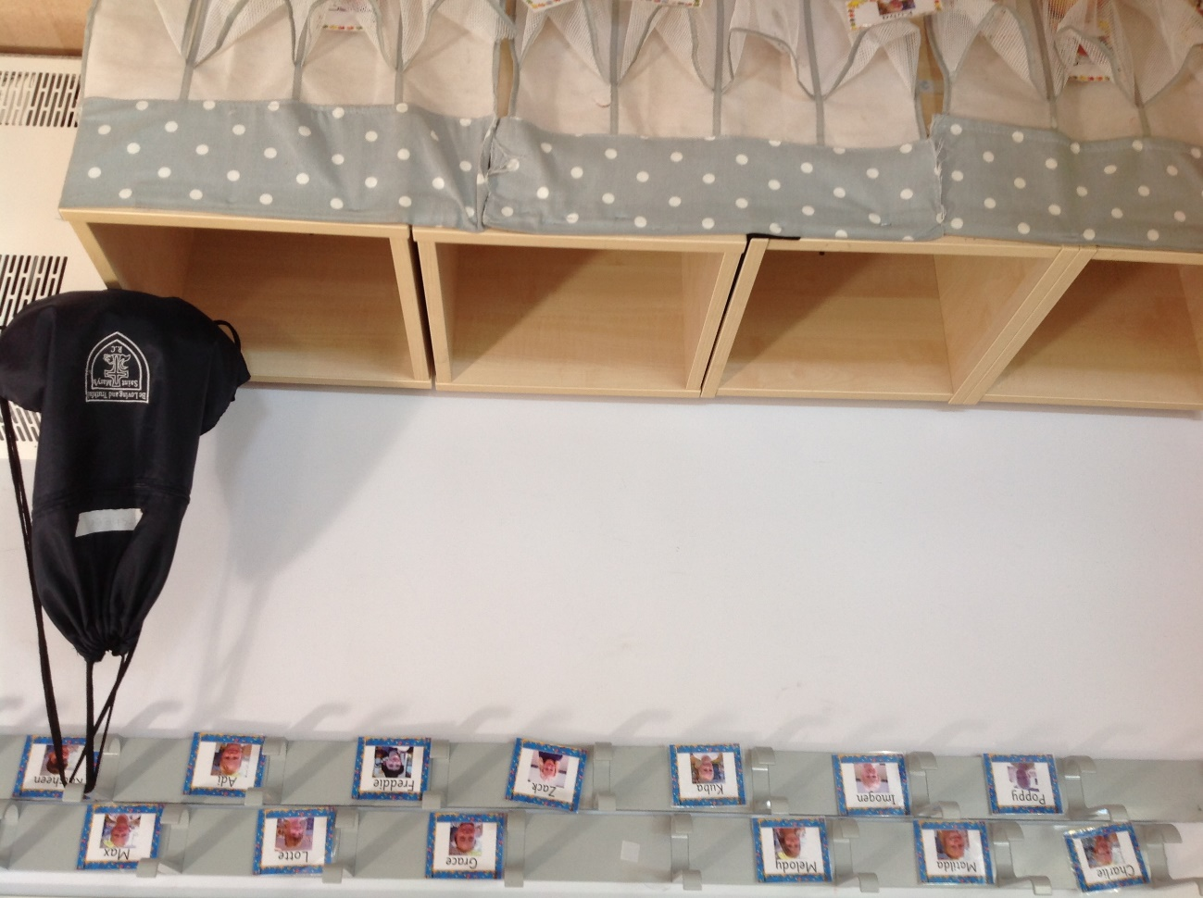
You will have a peg to put your coat on and if you bring a lunchbox you can put it in the box under your peg.

We have our own toilets in our classroom. You can wash your hands here before we have snack.
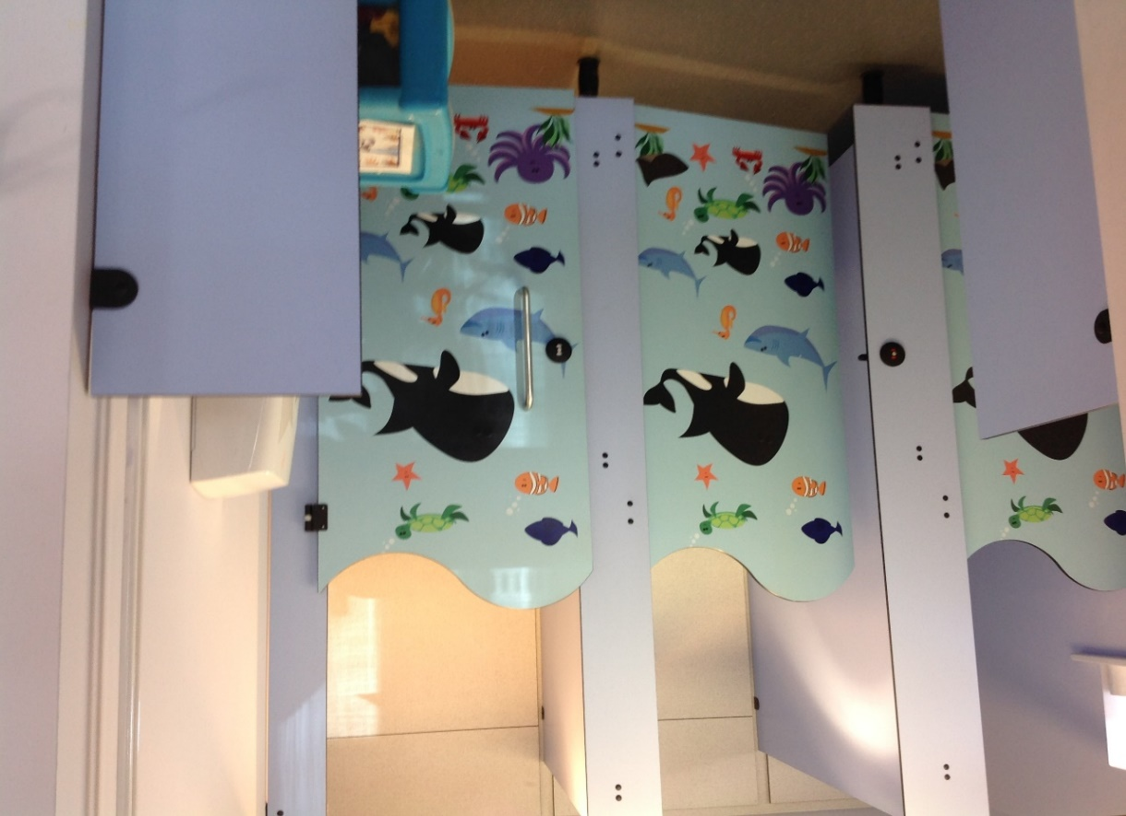

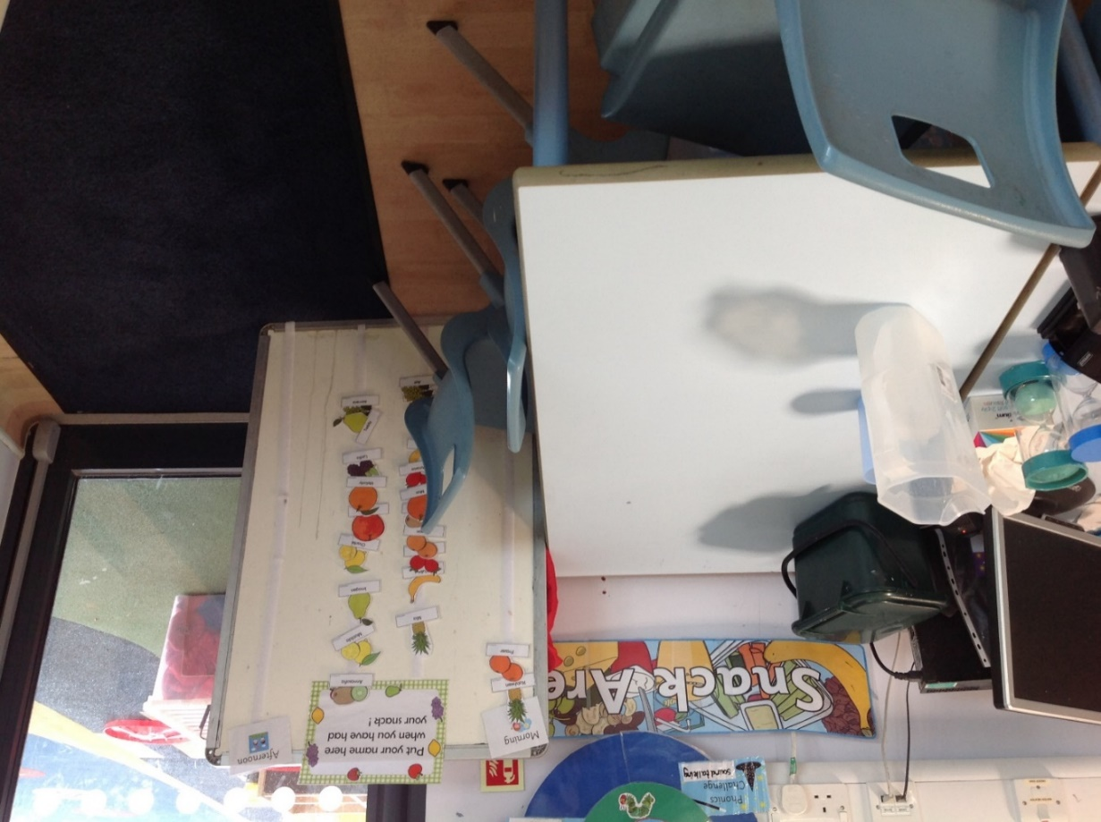
This is our snack table. You can have a snack and drink here in the morning and in the afternoon.
This is the gate which you come through when school begins. It is next to your preschool. This is where who ever is collecting you from school will wait at the end of the day also.
