PSHE  This term we will be focusing on settling into school life and becoming more confident in our school routine. Talking about our school rules and why they are so important to follow. We will also be beginning to identify our feelings and others. | Expressive Arts and Design  We will be working on the following projects to help encourage the children’s creative development;  Self-portraits, colour mixing, junk modelling.  In our music lessons we will be;  Listening and responding to music, changing our voices and keeping to a simple rhythm. | Understanding the World  We will be looking at our families and how they are all different and unique. We will look at celebrations that take place at this time of year such as bonfire night and Christmas. We will look at the seasonal changes that occur as we move into autumn and winter. We will focus on identifying parts of the body, how we have grown and explore our 5 senses.
RE  Our two topics this term are called Myself and Welcome. We will be exploring the ideas that God knows our name and loves each of us. We will then look at Baptisms and look forward to Jesus’ birth. | 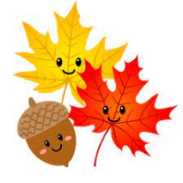  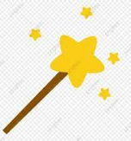  Magical Me & Autumn Changes | Communication and Language  This term will we be singing familiar songs and nursery rhymes, listening to stories, talking about our class routines. We will also focus on listening to and following instructions.
Maths  This term in maths we will be focusing on the numbers to 5. We will be comparing ordering, grouping and comparing the numbers to 5. We will also be working on our careful counting skills and subitising the numbers up to 10. | Physical Development  We will be doing lots of activities to improve our fine motor skills. This will involve lots of ‘funky finger’ challenges and our dough disco sessions. We will also be working on our gross motor skills through play in the outdoor area and in our PE lessons. | Literacy  This term in Literacy we will be focusing on learning set 1 of our sounds in our Read, Write Inc lessons.  We will also be learning to read simple words using our ‘Fred Talk’ skills of segmenting and blending.  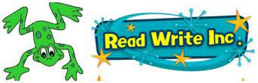  We will be marking making during our play and begin learning our handwriting rhymes to help us form letters and focus on writing some or all of our name.
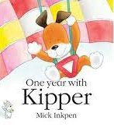
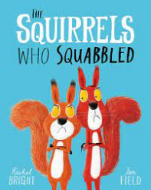
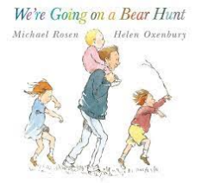
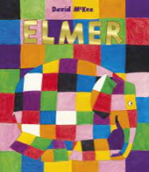
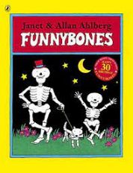
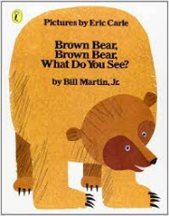
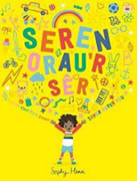
Key Books

